

**Project Report –** Responsive Restaurant menu page

**1. Title**

Responsive Restaurant menu page

**Submitted by :**

1. A Aaryan Dharrmik(2460301, a.aaryan@btech.christuniversity.in)
2. Richard Raju(2460432, richard.raju@btech.christuniversity.in)
3. Neil Joseph Joe(2460412, neil.joseph@btech.christuniversity.in)

**Course :** UI/UX Fundamentals

**Instructor name : Mrs. Nagaveena**

**Institution :** CHRIST(Deemed-to-be University) Bangalore Kengeri Campus

**Date of submission :** 13/08/2025

***Abstract***

This project involves the design and development of a fully responsive, single-page restaurant menu using only **HTML and CSS**. The goal was to create an elegant and user-friendly interface that clearly displays menu items categorized into Appetizers, Main Courses, Desserts, and Beverages. The core technologies leveraged were **HTML5** for structuring the content and **CSS3**, specifically CSS Grid and Media Queries, for the responsive layout and styling. The final outcome is a visually appealing and easy-to-navigate static webpage that provides an excellent user experience on desktops, tablets, and mobile devices.

***Objectives***

The primary objectives for this project were:

* To design a user-friendly and aesthetically pleasing menu interface using modern UI principles.
* To develop a fully responsive layout using CSS Grid that adapts seamlessly to different screen sizes.
* To implement structured and semantic HTML using elements like <header> and <section> for better organization and accessibility.
* To apply custom CSS styling for branding, layout, hover effects, and responsive behavior.
* To ensure high readability and accessibility across all devices through responsive typography and a clean layout.

***Scope of the Project***

This project's scope is strictly defined to focus on the front-end presentation of a static menu.

* The work is **focused on front-end design and layout only**.
* There is **no JavaScript for interactivity** or server-side integration for dynamic content.
* The design is intended for optimal viewing on **desktop and mobile viewports**.
* The project was built using **pure HTML and CSS code**, with the only external dependency being Google Fonts for typography.

***Tools & Technologies Used***

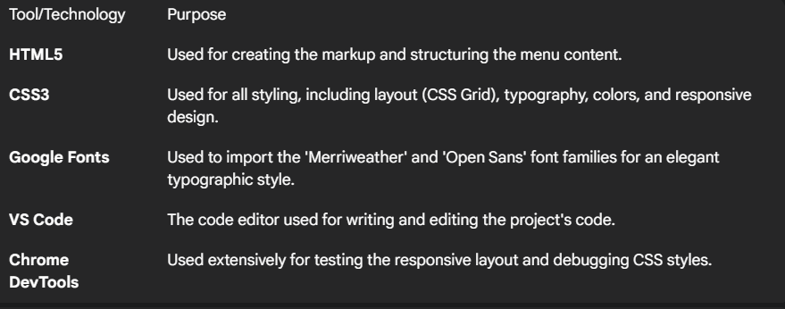

***HTML Structure Overview***

The HTML document is structured semantically to ensure clarity and accessibility.

* It uses semantic tags including **<header>** for the main title and **<section>** to group each menu category (e.g., Appetizers, Main Course).
* The page is structured into reusable sections, with each containing a heading and a grid of menu items.

**Tools & Technologies Used**

The following tools and technologies were used to complete this project:

| Tool/Technology | Purpose |
| --- | --- |
| **HTML5** | Used for creating the markup and structuring the menu content. |
| **CSS3** | Used for all styling, including layout (CSS Grid), typography, colors, and responsive design. |
| **Google Fonts** | Used to import the 'Merriweather' and 'Open Sans' font families for an elegant typographic style. |
| **VS Code** | The code editor used for writing and editing the project's code. |
| **Chrome DevTools** | Used extensively for testing the responsive layout and debugging CSS styles. |

Export to Sheets

**HTML & CSS Strategy**

**HTML Structure Overview :**

The HTML document is structured semantically to ensure clarity and accessibility.

* It uses semantic tags including **<header>** for the main title and **<section>** to group each menu category (e.g., Appetizers, Main Course).
* The page is structured into reusable sections, with each containing a heading and a grid of menu items.

***CSS Styling Strategy***

The styling was implemented using an internal stylesheet within the <style> tag for simplicity.

* The styling is organized with rule sets for global styles, header, menu sections, and individual menu cards.
* **Key techniques used include:**
  + **CSS Grid** to create a flexible and responsive column layout for the menu items.
  + **Media Queries** to adapt the layout for mobile devices (screens under 480px wide), switching from a grid to a single-column view.
  + **Hover effects and transitions** on the menu cards to provide visual feedback to the user.
  + A **mobile-first consideration** in the responsive design, ensuring the menu is perfectly usable on small screens.

***Key Features***

* The final menu page includes several key features designed to enhance the user experience.

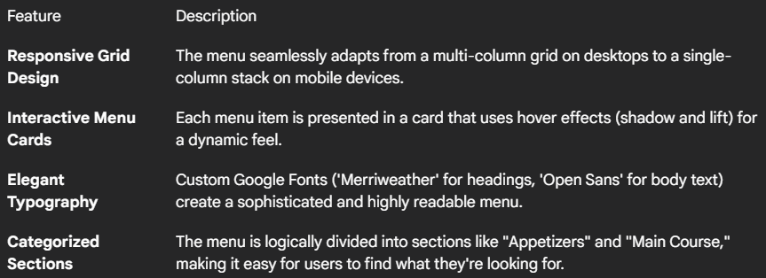

***Challenges Faced & Solutions***

Here are some of the challenges encountered and how they were solved.

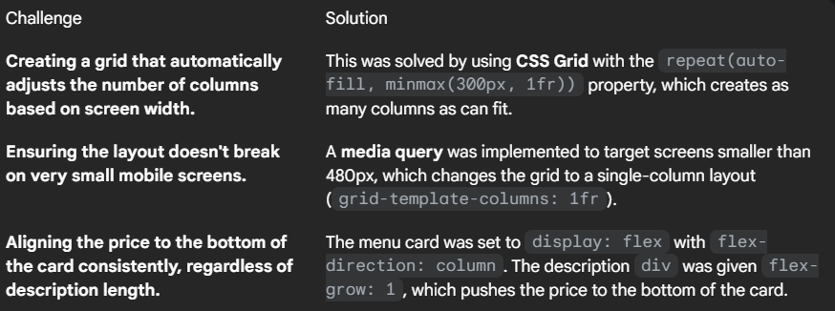

**Outcome**

* The project successfully resulted in a **clean, consistent, and visually engaging front-end layout** for a restaurant menu.
* All key components and responsive behaviors were achieved as intended, using **only HTML and CSS**.
* Through this project, I gained a much deeper practical knowledge of **CSS Grid, responsive design, and the importance of UI hierarchy** and typography.

***Future Enhancements***

While the current project is complete, there are several potential enhancements for the future:

* Add **JavaScript to enable menu filtering** (e.g., view vegetarian or gluten-free items only).
* Implement a **"light/dark mode" theme toggler** for user preference.
* Integrate a **backend system** (like Node.js or PHP) to allow a restaurant owner to add, edit, or remove menu items through a CMS.
* Add subtle animations or transitions to make the page feel more dynamic.

***Sample Code***

* Here are two key code snippets from the project.
* **Snippet 1: The Responsive CSS Grid** This CSS code defines the responsive grid for the menu items and the media query that adjusts it for mobile screens.

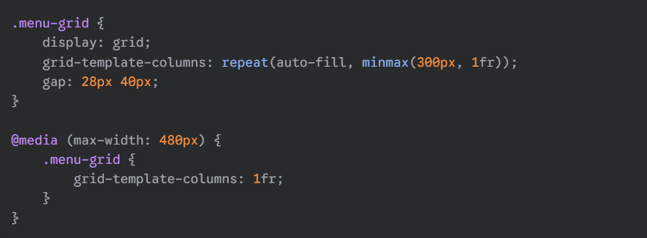

**Snippet 2:**

**HTML and CSS for a Menu Card** This snippet shows the HTML structure for a single menu item and the CSS that styles it, including the hover effect.

**HTML**

<div class="menu-card"> <div class="menu-name">Garlic Bread</div> <div class="menu-description">Freshly baked bread brushed with garlic butter and herbs.</div> <div class="price">$5.99</div> </div>

**CSS**

/* CSS for the card */ .menu-card { padding: 20px 25px; background-color: white; border-radius: 14px; box-shadow: 0 6px 12px rgba(171, 139, 102, 0.1); display: flex; flex-direction: column; } .menu-card:hover { box-shadow: 0 12px 24px rgba(194, 155, 90, 0.25); transform: translateY(-6px); transition: all 0.3s ease;

**Conclusion :**

This project details the design and development of a fully responsive, single-page restaurant menu using only HTML and CSS. The project focused on creating an elegant and user-friendly interface that clearly displays menu items, leveraging HTML5 for structure and CSS3 (specifically CSS Grid and Media Queries) for responsive layout and styling. The report outlines the project's objectives, scope (emphasizing front-end design without JavaScript or server-side integration), and the tools and technologies used, including HTML5, CSS3, Google Fonts, VS Code, and Chrome DevTools. It also describes the HTML and CSS strategies employed, highlighting semantic HTML structure and CSS Grid for layout with media queries for responsiveness. The report concludes by presenting the project's successful outcome in achieving a clean, consistent, and visually engaging front-end layout, and discusses potential future enhancements such as adding JavaScript for filtering, a light/dark mode toggler, and backend integration.

OUTPUT: 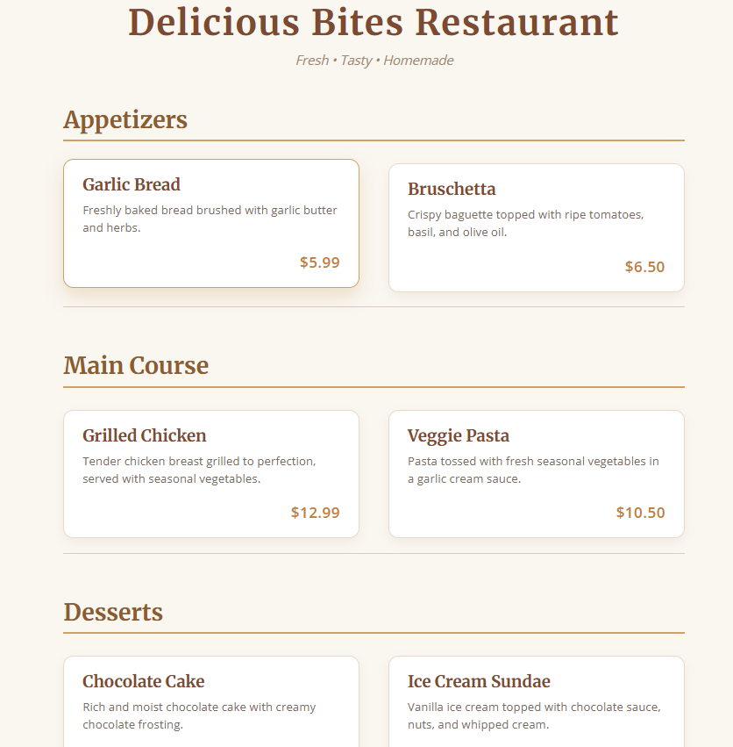

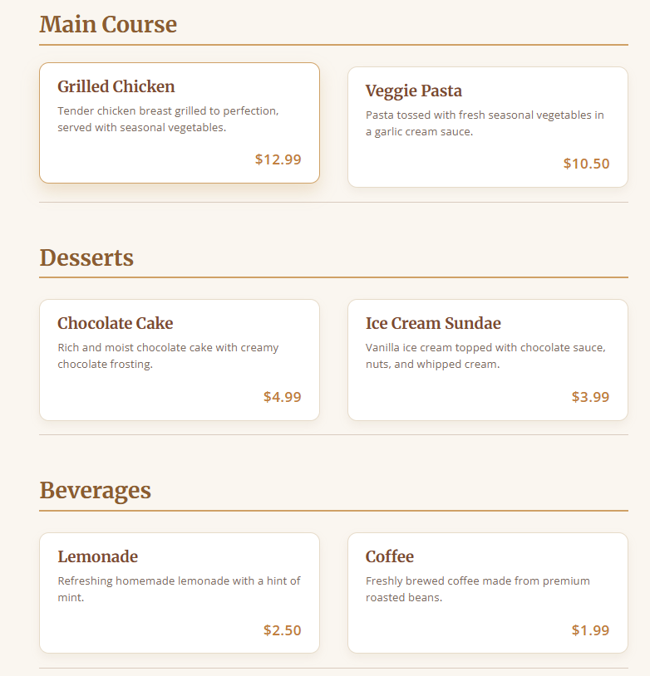

**References :**

L&T LMS : https://learn.lntedutech.com/Learner/MyCourse